

Geophysical Research Letters
Supporting Information for
Dependence of mineral dissolution rates on two-phase hydrodynamics in single pores
Xin Wang¹, Hang Deng^{1,2,3}
1. Department of Energy and Resources Engineering, School of Mechanics and Engineering Science, Peking University, Beijing, PR China
2. Institute of Energy, Peking University, Beijing, PR China
3. Institute of Carbon Neutrality, Peking University, Beijing, PR China

Contents of this file

Text S1 to S7
Figures S1 to S8
Tables S1 to S6

Introduction
The supporting information provides details about the experimental and simulation setups, the thermodynamic and kinetic data of the geochemical reactions, mesh convergence test, 2D and 3D simulation comparison, experimental slug length measurements, velocity profiles of selected simulations, and mass transfer coefficients from the simulations in relation to theoretical calculations.

Text S1
Table S1 and S2 summarize the experimental and simulation conditions. The experiments were performed using 3 channels under 17 different flow conditions for two-phase flow and the corresponding single-phase flow. Table S1 also reports the Reynolds number and capillary number at each condition. Three types of simulations were performed: single-phase flow simulation, T-junction two-phase flow simulations (TJ), and two-phase flow simulations using the square wave (SW) velocity conditions. In the TJ two-phase flow simulations, the slug length reported is what was formed in the simulations; while in the SW simulations, the slug length was user-specified.
Table S3 and S4 report the physical property and boundary conditions set for the simulation.
Table S5 and S6 report the equilibrium and kinetic coefficients used in the simulations, following (Li et al., 2022).
Table S1. Summary of all experimental conditions. For experimental case number i-j, i denotes the channel number; j is the numbering of different flow conditions.
Experimental case number | Single-phase flow rates | Two-phase aqueous flow rate | Two-phase air flow rate | Reynolds number |  | Capillary number
Experimental case number | Single-phase flow rates | 10mmol/L NaCl, pH=5 | air | Single-phase | Two-phase | Two-phase
\ | ul/min | ul/min | ul/min | \ | \
1-1 | 10 | 10 | 10 | 1.52E-01 | 3.03E-01 | 3.01E-06
1-2 | 20 | 20 | 20 | 3.03E-01 | 6.06E-01 | 6.02E-06
1-3 | 40 | 40 | 40 | 6.07E-01 | 1.21E+00 | 1.20E-05
1-4 | 80 | 80 | 80 | 1.21E+00 | 2.42E+00 | 2.41E-05
1-5 | 100 | 100 | 100 | 1.52E+00 | 3.03E+00 | 3.01E-05
1-6 | 200 | 200 | 200 | 3.03E+00 | 6.06E+00 | 6.02E-05
1-7 | 300 | 300 | 300 | 4.55E+00 | 9.09E+00 | 9.03E-05
1-8 | 400 | 400 | 400 | 6.07E+00 | 1.21E+01 | 1.20E-04
1-9 | 500 | 500 | 500 | 7.58E+00 | 1.51E+01 | 1.50E-04
1-10 | 600 | 600 | 600 | 9.10E+00 | 1.82E+01 | 1.81E-04
1-11 | 800 | 800 | 800 | 1.21E+01 | 2.42E+01 | 2.41E-04
1-12 | - | 1000 | 1000 | - | 3.03E+01 | 3.01E-04
1-13 | 2000 | 2000 | 2000 | 3.03E+01 | 6.06E+01 | 6.02E-04
1-14 | 3000 | 3000 | 3000 | 4.55E+01 | 9.09E+01 | 9.03E-04
1-15 | 5000 | 5000 | 5000 | 7.58E+01 | 1.51E+02 | 1.50E-03
1-16 | 6000 | 6000 | 6000 | 9.10E+01 | 1.82E+02 | 1.81E-03
1-17 | 10000 | 10000 | 10000 | 1.52E+02 | 3.03E+02 | 3.01E-03
2-1 | 10 | 10 | 10 | 1.18E-01 | 2.36E-01 | 1.82E-06
2-2 | 20 | 20 | 20 | 2.36E-01 | 4.72E-01 | 3.64E-06
2-3 | 40 | 40 | 40 | 4.72E-01 | 9.44E-01 | 7.28E-06
2-4 | 80 | 80 | 80 | 9.44E-01 | 1.89E+00 | 1.46E-05
2-5 | 100 | 100 | 100 | 1.18E+00 | 2.36E+00 | 1.82E-05
2-6 | 200 | 200 | 200 | 2.36E+00 | 4.72E+00 | 3.64E-05
2-7 | 300 | 300 | 300 | 3.54E+00 | 7.08E+00 | 5.46E-05
2-8 | 400 | 400 | 400 | 4.72E+00 | 9.44E+00 | 7.28E-05
2-9 | 500 | 500 | 500 | 5.90E+00 | 1.18E+01 | 9.10E-05
2-10 | 600 | 600 | 600 | 7.08E+00 | 1.42E+01 | 1.09E-04
2-11 | 800 | 800 | 800 | 9.44E+00 | 1.89E+01 | 1.46E-04
2-12 | 1000 | 1000 | 1000 | 1.18E+01 | 2.36E+01 | 1.82E-04
2-13 | 2000 | 2000 | 2000 | 2.36E+01 | 4.72E+01 | 3.64E-04
2-14 | 3000 | 3000 | 3000 | 3.54E+01 | 7.08E+01 | 5.46E-04
2-15 | 5000 | 5000 | 5000 | 5.90E+01 | 1.18E+02 | 9.10E-04
2-16 | 6000 | 6000 | 6000 | 7.08E+01 | 1.42E+02 | 1.09E-03
2-17 | 10000 | 10000 | 10000 | 1.18E+02 | 2.36E+02 | 1.82E-03
3-1 | 10 | 10 | 10 | 1.63E-01 | 3.27E-01 | 3.49E-06
3-2 | 20 | 20 | 20 | 3.27E-01 | 6.53E-01 | 6.98E-06
3-3 | 40 | 40 | 40 | 6.53E-01 | 1.31E+00 | 1.40E-05
3-4 | 80 | 80 | 80 | 1.31E+00 | 2.61E+00 | 2.79E-05
3-5 | 100 | 100 | 100 | 1.63E+00 | 3.27E+00 | 3.49E-05
3-6 | 200 | 200 | 200 | 3.27E+00 | 6.53E+00 | 6.98E-05
3-7 | 300 | 300 | 300 | 4.90E+00 | 9.80E+00 | 1.05E-04
3-8 | 400 | 400 | 400 | 6.53E+00 | 1.31E+01 | 1.40E-04
3-9 | 500 | 500 | 500 | 8.17E+00 | 1.63E+01 | 1.74E-04
3-10 | 600 | 600 | 600 | 9.80E+00 | 1.96E+01 | 2.09E-04
3-11 | 800 | 800 | 800 | 1.31E+01 | 2.61E+01 | 2.79E-04
3-12 | 1000 | 1000 | 1000 | 1.63E+01 | 3.27E+01 | 3.49E-04
3-13 | 2000 | 2000 | 2000 | 3.27E+01 | 6.53E+01 | 6.98E-04
3-14 | 3000 | 3000 | 3000 | 4.90E+01 | 9.80E+01 | 1.05E-03
3-15 | 5000 | 5000 | 5000 | 8.17E+01 | 1.63E+02 | 1.74E-03
3-16 | 6000 | 6000 | 6000 | 9.80E+01 | 1.96E+02 | 2.09E-03
3-17 | 10000 | 10000 | 10000 | 1.63E+02 | 3.27E+02 | 3.49E-03

Table S2. Simulation conditions. For the simulation case number i-j-k, i is the channel number; j=1 for single-phase flow simulations, 2 for T-junction two-phase flow simulations, 3 for square wave two-phase flow simulations; k denotes different flow conditions.
Simulation number | channel length | diameter | single phase flow rates | two phase aqueous inlet | two phase air inlet | slug length
 | m | m | m/s | m/s | m/s | m
1-1-1 | 0.0091 | 0.0014 | 1.08E-04
1-1-2 | 0.0091 | 0.0014 | 2.17E-04
1-1-3 | 0.0091 | 0.0014 | 4.33E-04
1-1-4 | 0.0091 | 0.0014 | 8.67E-04
1-1-5 | 0.0091 | 0.0014 | 1.08E-03
1-1-6 | 0.0091 | 0.0014 | 2.17E-03
1-1-7 | 0.0091 | 0.0014 | 3.25E-03
1-1-8 | 0.0091 | 0.0014 | 4.33E-03
1-1-9 | 0.0091 | 0.0014 | 5.42E-03
1-1-10 | 0.0091 | 0.0014 | 6.50E-03
1-1-11 | 0.0091 | 0.0014 | 8.67E-03
1-1-12 | 0.0091 | 0.0014 | 2.17E-02
1-1-13 | 0.0091 | 0.0014 | 3.25E-02
1-1-14 | 0.0091 | 0.0014 | 5.42E-02
1-1-15 | 0.0091 | 0.0014 | 6.50E-02
1-1-16 | 0.0091 | 0.0014 | 1.08E-01
2-1-1 | 0.01209 | 0.0018 | 6.55E-05
2-1-2 | 0.01209 | 0.0018 | 1.31E-04
2-1-3 | 0.01209 | 0.0018 | 2.62E-04
2-1-4 | 0.01209 | 0.0018 | 5.24E-04
2-1-5 | 0.01209 | 0.0018 | 6.55E-04
2-1-6 | 0.01209 | 0.0018 | 1.31E-03
2-1-7 | 0.01209 | 0.0018 | 1.97E-03
2-1-8 | 0.01209 | 0.0018 | 2.62E-03
2-1-9 | 0.01209 | 0.0018 | 3.28E-03
2-1-10 | 0.01209 | 0.0018 | 3.93E-03
2-1-11 | 0.01209 | 0.0018 | 5.24E-03
2-1-12 | 0.01209 | 0.0018 | 6.55E-03
2-1-13 | 0.01209 | 0.0018 | 1.31E-02
2-1-14 | 0.01209 | 0.0018 | 1.97E-02
2-1-15 | 0.01209 | 0.0018 | 3.28E-02
2-1-16 | 0.01209 | 0.0018 | 3.93E-02
2-1-17 | 0.01209 | 0.0018 | 6.55E-02
3-1-1 | 0.00893 | 0.0013 | 1.26E-04
3-1-2 | 0.00893 | 0.0013 | 2.51E-04
3-1-3 | 0.00893 | 0.0013 | 5.03E-04
3-1-4 | 0.00893 | 0.0013 | 1.01E-03
3-1-5 | 0.00893 | 0.0013 | 1.26E-03
3-1-6 | 0.00893 | 0.0013 | 2.51E-03
3-1-7 | 0.00893 | 0.0013 | 3.77E-03
3-1-8 | 0.00893 | 0.0013 | 5.03E-03
3-1-9 | 0.00893 | 0.0013 | 6.28E-03
3-1-10 | 0.00893 | 0.0013 | 7.54E-03
3-1-11 | 0.00893 | 0.0013 | 1.01E-02
3-1-12 | 0.00893 | 0.0013 | 1.26E-02
3-1-13 | 0.00893 | 0.0013 | 2.51E-02
3-1-14 | 0.00893 | 0.0013 | 3.77E-02
3-1-15 | 0.00893 | 0.0013 | 6.28E-02
3-1-16 | 0.00893 | 0.0013 | 7.54E-02
3-1-17 | 0.00893 | 0.0013 | 1.26E-01
4-1-1 | 0.0001 | 0.0001 | 0.001
4-1-2 | 0.0001 | 0.0001 | 0.01
4-1-3 | 0.0001 | 0.0001 | 0.1
5-1-1 | 0.001 | 0.001 | 0.001
5-1-2 | 0.001 | 0.001 | 0.01
5-1-3 | 0.001 | 0.001 | 0.1
6-1-1 | 0.01 | 0.001 | 0.001
6-1-2 | 0.01 | 0.001 | 0.01
6-1-3 | 0.01 | 0.001 | 0.1
1-2-1 | 0.0091 | 0.0014 |  | 1.08E-03 | 1.08E-03 | 0.0041
1-2-2 | 0.0091 | 0.0014 |  | 2.17E-03 | 2.17E-03 | 0.0041
1-2-3 | 0.0091 | 0.0014 |  | 1.08E-02 | 1.08E-02 | 0.0041
1-2-4 | 0.0091 | 0.0014 |  | 2.17E-02 | 2.17E-02 | 0.0075
1-2-5 | 0.0091 | 0.0014 |  | 3.25E-02 | 3.25E-02 | 0.0058
1-2-6 | 0.0091 | 0.0014 |  | 5.42E-02 | 5.42E-02 | 0.0051
1-2-7 | 0.0091 | 0.0014 |  | 6.50E-02 | 6.50E-02 | 0.0032
1-2-8 | 0.0091 | 0.0014 |  | 1.08E-01 | 1.08E-01 | 0.0028
2-2-1 | 0.01209 | 0.0018 |  | 6.55E-04 | 6.55E-04 | 0.0057
2-2-2 | 0.01209 | 0.0018 |  | 1.31E-03 | 1.31E-03 | 0.0041
2-2-3 | 0.01209 | 0.0018 |  | 6.55E-03 | 6.55E-03 | 0.0045
2-2-4 | 0.01209 | 0.0018 |  | 1.31E-02 | 1.31E-02 | 0.006
2-2-5 | 0.01209 | 0.0018 |  | 1.97E-02 | 1.97E-02 | 0.0054
2-2-6 | 0.01209 | 0.0018 |  | 3.28E-02 | 3.28E-02 | 0.0044
2-2-7 | 0.01209 | 0.0018 |  | 3.93E-02 | 3.93E-02 | 0.0043
2-2-8 | 0.01209 | 0.0018 |  | 6.55E-02 | 6.55E-02 | 0.0043
3-2-1 | 0.00893 | 0.0013 |  | 1.26E-03 | 1.26E-03 | 0.0041
3-2-2 | 0.00893 | 0.0013 |  | 2.51E-03 | 2.51E-03 | 0.0043
3-2-3 | 0.00893 | 0.0013 |  | 1.26E-02 | 1.26E-02 | 0.0048
3-2-4 | 0.00893 | 0.0013 |  | 2.51E-02 | 2.51E-02 | 0.006
3-2-5 | 0.00893 | 0.0013 |  | 3.77E-02 | 3.77E-02 | 0.0054
3-2-6 | 0.00893 | 0.0013 |  | 6.28E-02 | 6.28E-02 | 0.0032
3-2-7 | 0.00893 | 0.0013 |  | 7.54E-02 | 7.54E-02 | 0.0045
3-2-8 | 0.00893 | 0.0013 |  | 1.26E-01 | 1.26E-01 | 0.0043
1-3-1 | 0.0091 | 0.0014 |  | 2.17E-02 | 2.17E-02 | 0.005
1-3-2 | 0.0091 | 0.0014 |  | 2.17E-02 | 2.17E-02 | 0.01
1-3-3 | 0.0091 | 0.0014 |  | 2.17E-02 | 2.17E-02 | 0.02
1-3-4 | 0.0091 | 0.0014 |  | 2.17E-02 | 2.17E-02 | 0.03
1-3-5 | 0.0091 | 0.0014 |  | 2.17E-02 | 2.17E-02 | 0.04
1-3-6 | 0.0091 | 0.0014 |  | 6.50E-02 | 6.50E-02 | 0.008
1-3-7 | 0.0091 | 0.0014 |  | 6.50E-02 | 6.50E-02 | 0.013
1-3-8 | 0.0091 | 0.0014 |  | 6.50E-02 | 6.50E-02 | 0.018
1-3-9 | 0.0091 | 0.0014 |  | 6.50E-02 | 6.50E-02 | 0.025
1-3-10 | 0.0091 | 0.0014 |  | 6.50E-02 | 6.50E-02 | 0.03
1-3-11 | 0.0091 | 0.0014 |  | 1.08E-01 | 1.08E-01 | 0.016
2-3-1 | 0.01209 | 0.0018 |  | 1.31E-02 | 1.31E-02 | 0.001
2-3-2 | 0.01209 | 0.0018 |  | 1.31E-02 | 1.31E-02 | 0.002
2-3-3 | 0.01209 | 0.0018 |  | 1.31E-02 | 1.31E-02 | 0.004
2-3-4 | 0.01209 | 0.0018 |  | 1.31E-02 | 1.31E-02 | 0.008
2-3-5 | 0.01209 | 0.0018 |  | 1.31E-02 | 1.31E-02 | 0.016
2-3-6 | 0.01209 | 0.0018 |  | 3.93E-02 | 3.93E-02 | 0.001
2-3-7 | 0.01209 | 0.0018 |  | 3.93E-02 | 3.93E-02 | 0.002
2-3-8 | 0.01209 | 0.0018 |  | 3.93E-02 | 3.93E-02 | 0.004
2-3-9 | 0.01209 | 0.0018 |  | 3.93E-02 | 3.93E-02 | 0.008
2-3-10 | 0.01209 | 0.0018 |  | 3.93E-02 | 3.93E-02 | 0.016
2-3-11 | 0.01209 | 0.0018 |  | 6.55E-02 | 6.55E-02 | 0.008
3-3-1 | 0.00893 | 0.0013 |  | 2.51E-02 | 2.51E-02 | 0.005
3-3-2 | 0.00893 | 0.0013 |  | 2.51E-02 | 2.51E-02 | 0.01
3-3-3 | 0.00893 | 0.0013 |  | 2.51E-02 | 2.51E-02 | 0.02
3-3-4 | 0.00893 | 0.0013 |  | 2.51E-02 | 2.51E-02 | 0.03
3-3-5 | 0.00893 | 0.0013 |  | 2.51E-02 | 2.51E-02 | 0.04
3-3-6 | 0.00893 | 0.0013 |  | 7.54E-02 | 7.54E-02 | 0.008
3-3-7 | 0.00893 | 0.0013 |  | 7.54E-02 | 7.54E-02 | 0.013
3-3-8 | 0.00893 | 0.0013 |  | 7.54E-02 | 7.54E-02 | 0.018
3-3-9 | 0.00893 | 0.0013 |  | 7.54E-02 | 7.54E-02 | 0.025
3-3-10 | 0.00893 | 0.0013 |  | 7.54E-02 | 7.54E-02 | 0.03
3-3-11 | 0.00893 | 0.0013 |  | 1.26E-01 | 1.26E-01 | 0.025
4-2-1 | 0.0001 | 0.0001 |  | 0.001 | 0.001 | 0.0002
4-2-2 | 0.0001 | 0.0001 |  | 0.001 | 0.001 | 0.0005
4-2-3 | 0.0001 | 0.0001 |  | 0.001 | 0.001 | 0.001
4-2-4 | 0.0001 | 0.0001 |  | 0.01 | 0.01 | 0.0002
4-2-5 | 0.0001 | 0.0001 |  | 0.01 | 0.01 | 0.0005
4-2-6 | 0.0001 | 0.0001 |  | 0.01 | 0.01 | 0.001
4-2-7 | 0.0001 | 0.0001 |  | 0.1 | 0.1 | 0.0002
4-2-8 | 0.0001 | 0.0001 |  | 0.1 | 0.1 | 0.0005
4-2-9 | 0.0001 | 0.0001 |  | 0.1 | 0.1 | 0.001
5-2-1 | 0.001 | 0.001 |  | 0.001 | 0.001 | 0.002
5-2-2 | 0.001 | 0.001 |  | 0.001 | 0.001 | 0.005
5-2-3 | 0.001 | 0.001 |  | 0.001 | 0.001 | 0.01
5-2-4 | 0.001 | 0.001 |  | 0.01 | 0.01 | 0.002
5-2-5 | 0.001 | 0.001 |  | 0.01 | 0.01 | 0.005
5-2-6 | 0.001 | 0.001 |  | 0.01 | 0.01 | 0.01
5-2-7 | 0.001 | 0.001 |  | 0.1 | 0.1 | 0.002
5-2-8 | 0.001 | 0.001 |  | 0.1 | 0.1 | 0.005
5-2-9 | 0.001 | 0.001 |  | 0.1 | 0.1 | 0.01
6-2-1 | 0.01 | 0.001 |  | 0.001 | 0.001 | 0.002
6-2-2 | 0.01 | 0.001 |  | 0.001 | 0.001 | 0.005
6-2-3 | 0.01 | 0.001 |  | 0.001 | 0.001 | 0.01
6-2-4 | 0.01 | 0.001 |  | 0.01 | 0.01 | 0.002
6-2-5 | 0.01 | 0.001 |  | 0.01 | 0.01 | 0.005
6-2-6 | 0.01 | 0.001 |  | 0.01 | 0.01 | 0.01
6-2-7 | 0.01 | 0.001 |  | 0.1 | 0.1 | 0.002
6-2-8 | 0.01 | 0.001 |  | 0.1 | 0.1 | 0.005
6-2-9 | 0.01 | 0.001 |  | 0.1 | 0.1 | 0.01

Table S3. Physical properties of the fluids and fluid-solid interfaces.
$$ρ_{w} [kg/m^{3}]$$ | $$ρ_{nw} [kg/m^{3}]$$ | $$μ_{w} [Pa∙s]$$ | $$μ_{nw} [Pa∙s]$$ | $$γ [N/m]$$ | $$θ$$
1000 | 1.0 | 1.05×10⁻³ | 1.55×10⁻⁵ | 0.072 | 60°

Table S4. Boundary conditions for the simulations.
 | inlet |  | wall | outlet
 | Single-phase | Two-phase | wall | outlet
Flow | constant | TJ: constant  SW: square wave | no-slip | zero gradient
Phase | α=1 | α_{air}=0  α_{aqueous}=1 | zero gradient | zero gradient
Pressure | zero gradient | zero gradient | zero gradient | 0
Concentration | constant | constant | zero gradient | zero gradient

Table S5. Calcite dissolution reactions, equilibrium constant, and kinetic coefficients.
Dissolution reaction | $$\log{K_{eq}}$$
$CaCO_{3}\left(s\right)+2H^{+}=Ca^{2+}+H_{2}CO_{3}\left(aq\right)$ | 8.16
Elementary reaction | $$\log{k}\left[mol/m^{2}⋅s\right]$$
$CaCO_{3}\left(s\right)+H^{+}⟺Ca^{2+}+HCO_{3}^{-}$ | $$k_{1}=-0.05$$
$CaCO_{3}\left(s\right)+H_{2}CO_{3}\left(aq\right)⟺Ca^{2+}+2HCO_{3}^{-}$ | $$k_{2}=-3.3$$
$CaCO_{3}\left(s\right)⟺Ca^{2+}+CO_{3}^{2-}$ | $$k_{3}=-6.19$$

Table S6. Aqueous reactions and the equilibrium constants.
Aqueous reaction | $$\log{K_{eq}}$$
$OH^{-}+H^{+}⇄H_{2}O$ | 13.99
$CO_{3}^{2-}++2H^{+}⇄H_{2}CO_{3}\left(aq\right)$ | 16.67
$HCO_{3}^{-}+H^{+}⇄H_{2}CO_{3}\left(aq\right)$ | 6.34
$CaCO_{3}\left(aq\right)+2H^{+}⇄Ca^{2+}+H_{2}CO_{3}\left(aq\right)$ | 13.35
$CaHCO_{3}^{-}+H^{+}⇄H_{2}CO_{3}\left(aq\right)+Ca^{2+}$ | 5.30
$CaOH^{+}+H^{+}⇄Ca^{2+}+H_{2}O$ | 12.85
$Ca{Cl}^{+}⇄Ca^{2+}+{Cl}^{-}$ |  | 0.7
$CaCl_{2}\left(aq\right)⇄Ca^{2+}+2{Cl}^{-}$ |  | 0.65
$NaCO_{3}^{-}+{2H}^{+}⇄H_{2}CO_{3}\left(aq\right)+Na^{+}$ |  | 16.16
$NaCl\left(aq\right)⇄Na^{+}+{Cl}^{-}$ |  | 0.78
$NaHCO_{3}^{-}+H^{+}⇄H_{2}CO_{3}\left(aq\right)+Na^{+}$ |  | 6.18

Text S2
Fig. S1 illustrates results from several other supplementary experiments. Fig. S1(a) shows contact angle measurements of water on polished surface of Iceland spar using sessile drop method (ZJ-7000). The average contact angle is 60.04°, rounded to 60°. Fig. S1(b) shows surface average reaction rate in single-phase flow calculated based on the bulk reaction rate and the calcite channel size.

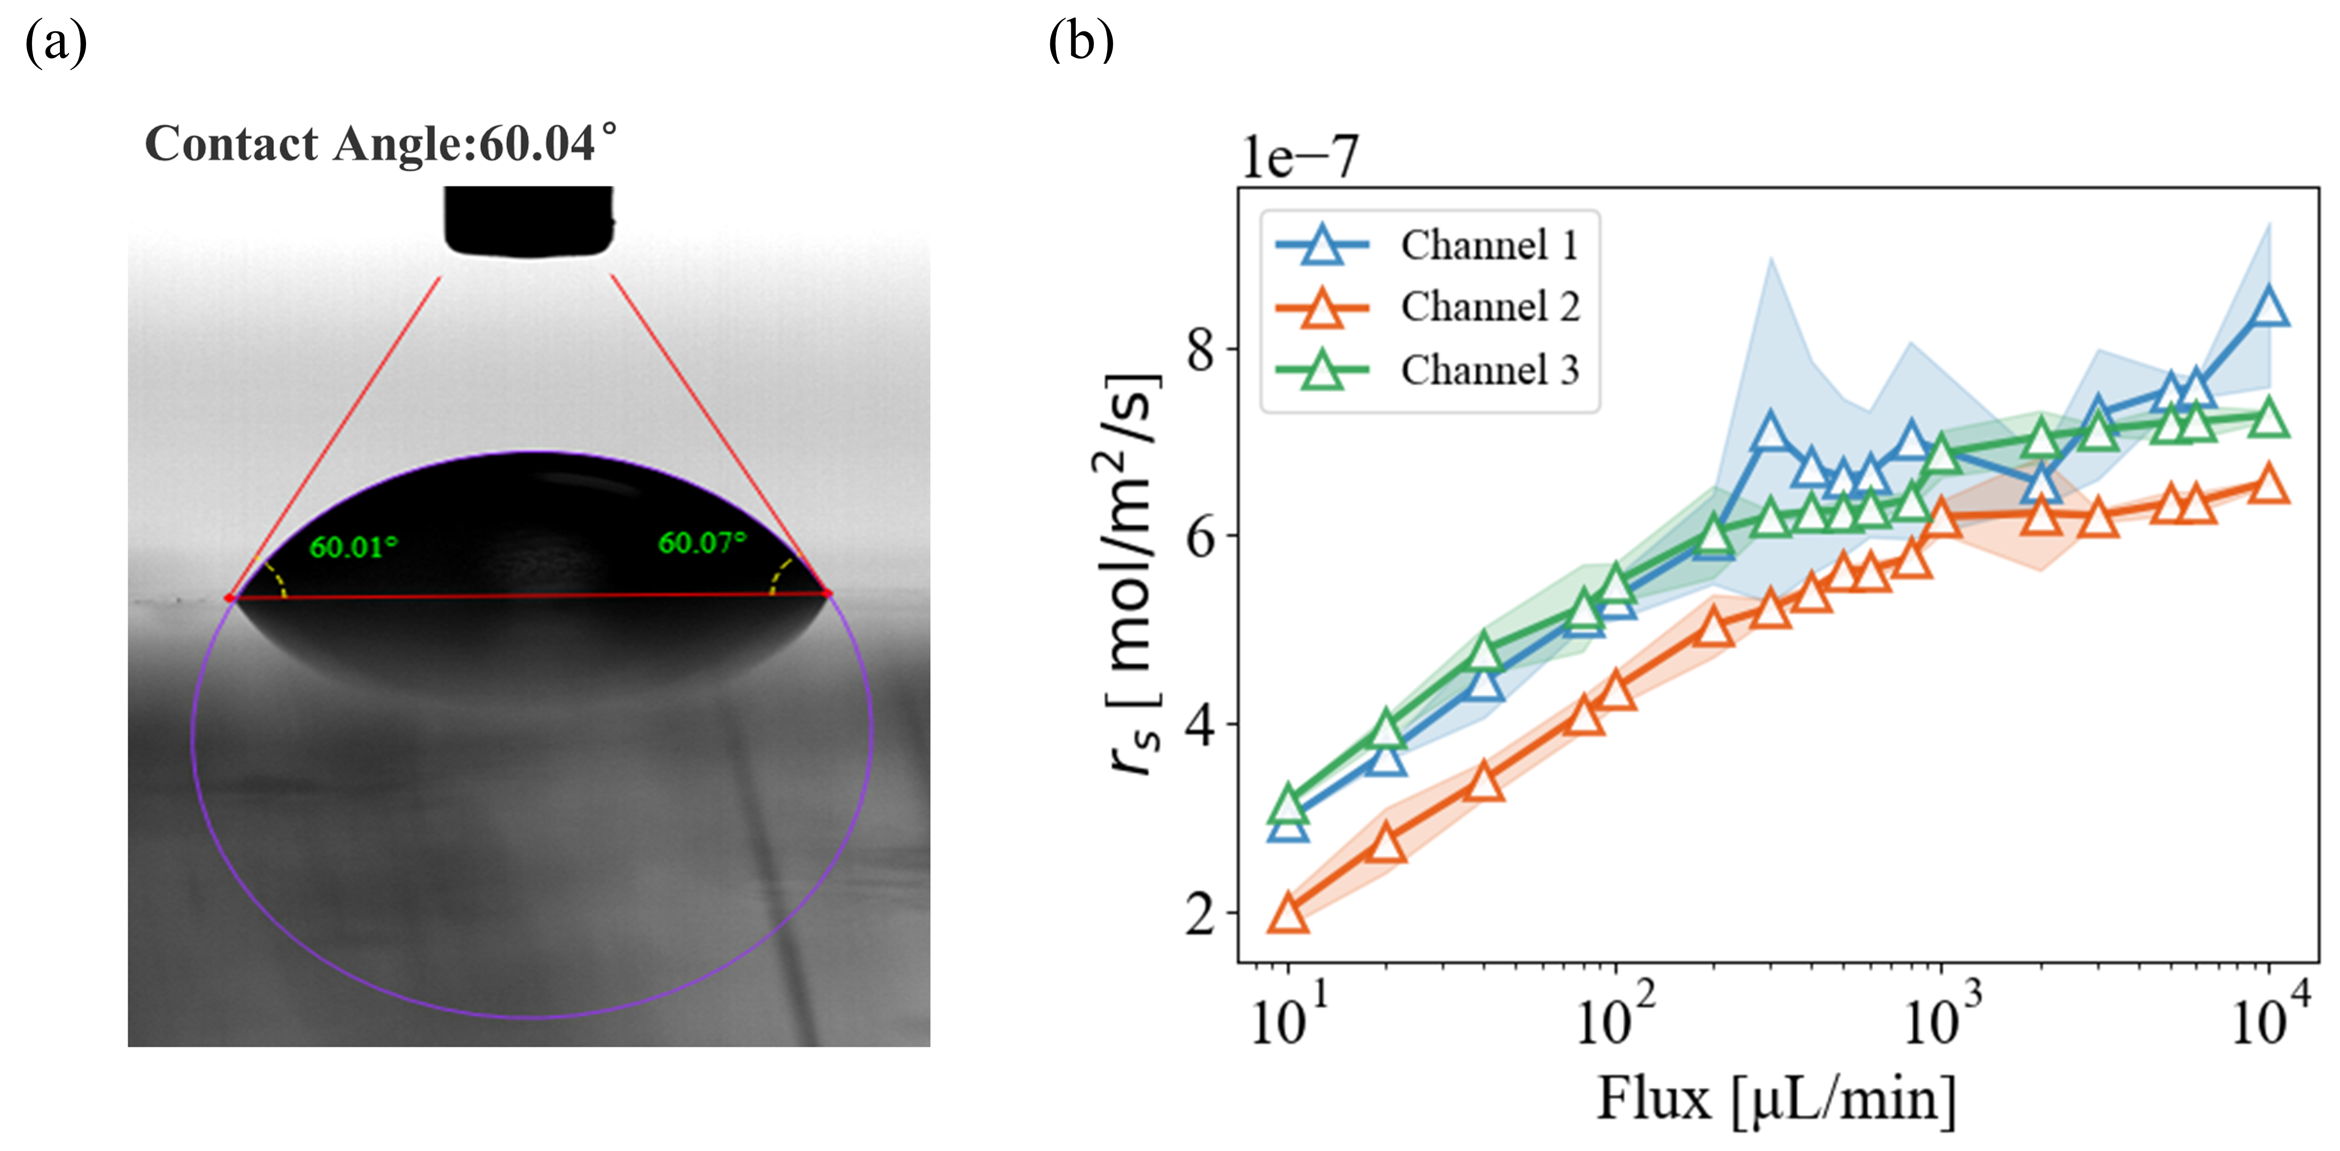
Figure S1. (a)Calcite contact angle measurement. (b)surface averaged reaction rate in single-phase flow

Text S3
Figure S2 shows the simulation results for single-phase and two-phase flow in Channel 2 at a flow velocity of 0.0131 m/s at different mesh resolutions. In the single-phase flow (Figure S2(a)), when the number of grid cells across the channel radius (y-direction) increase from 25 to 50, the surface area averaged reaction rate ($r_{s}$) increase slightly from 6.24×10⁻⁷ to 6.45×10⁻⁷ mol/m²/s, representing a difference of approximately 3.1%. This indicates that mesh convergence has been reached, and thus the single-phase flow simulations employed a resolution of 50 grids in the y-direction. For the two-phase flow simulation, with the number of grid cells in the y-direction being 50, 75, and 100, the values of steady state $r_{t}$are 1.40×10⁻⁶, 1.35×10⁻⁶, and 1.34×10⁻⁶ mol/m²/s, respectively. The differences are less than 5%, and considering the computational cost, we used 50 grids in the y-direction for the two-phase flow simulations.
Figure S3 shows the mesh of the 3D simulation and the comparison of $r_{t}$ between the 2D and 3D simulations in channel-2 at a flow velocity of 0.0131 m/s. In the 3D simulation, 30 grid cells were used across the diameter of the channel for computational efficiency. The average $r_{t}$ at the steady state from the 2D and 3D simulations are 1.40×10⁻⁶ and 1.46×10⁻⁶ mol/m²/s, respectively. The difference is less than 5%, which supports the use of 2D simulations to save computational cost.
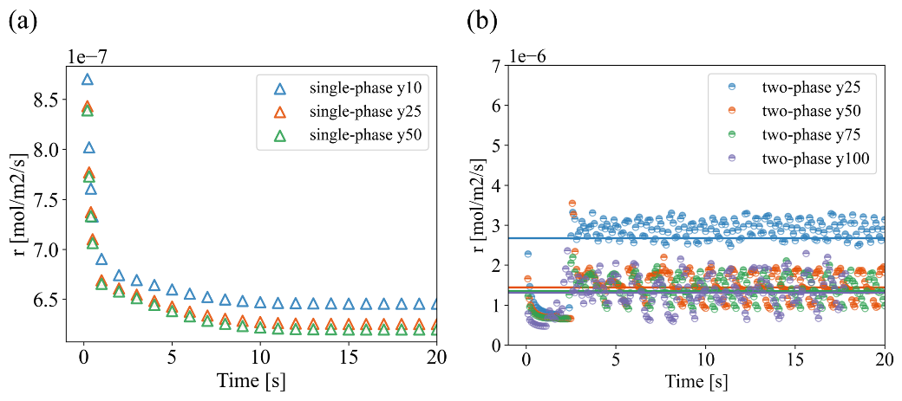
Figure S2. Mesh convergence tests of (a) the single-phase flow simulations for channel-2 at the flow velocity of 0.0131 m/s (simulation 2-1-13) and (b) the two-phase flow SW simulations for channel-2 at the flow velocity of 0.0131 m/s (simulation 2-3-3).
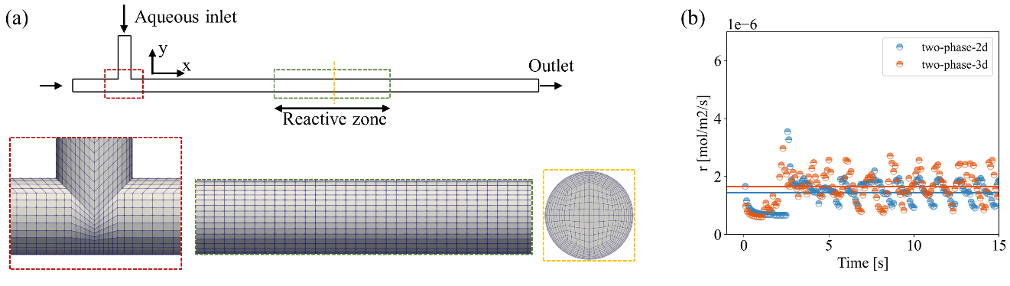
Figure S3. (a) illustration of the meshing of the 3D simulation, and (b) comparison of 2D and 3D SW simulation for two-phase flow for channel-2 at the flow velocity of 0.0131 m/s.
Text S4
Figure S4(a) illustrates the workflow for the determination of the slug lengths in the experiments. The time needed for an aqueous slug to pass through a given position in the channel was recorded from the video and used to calculate the length based on the flow rate. Ten measurements were taken for each case, and the average and standard deviations are shown in Figure S4(b).

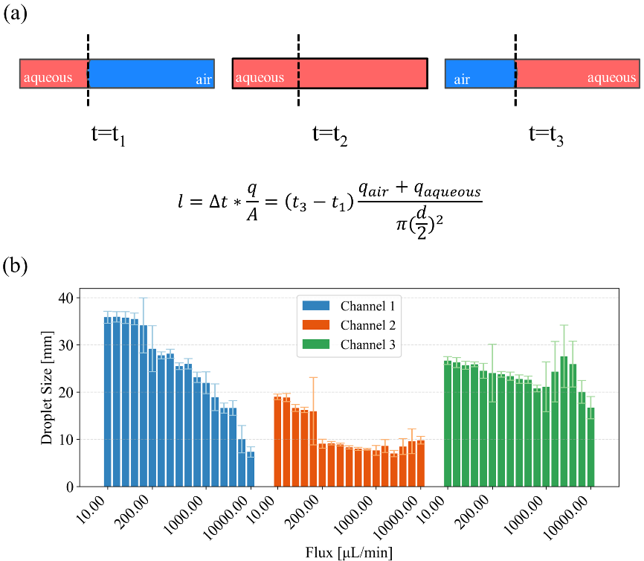
Figure S4. (a) illustration of workflow for the determination of the slug length, and (b) slug lengths for all experiments of the three channels at different flow rates.

Text S5
To better illustrate the effect of slug length on the reaction rate, SW simulations were performed for channel 1-3 at total flow rates of 2000 and 6000 μL/min with a range of different slug lengths (Figure S5). It can be observed that for all cases, the bulk reaction rate R decreases as the droplet size increases. When the droplet size used in the simulations is comparable to the experimental slug length, the simulated rates are in good agreement with the experimental results.
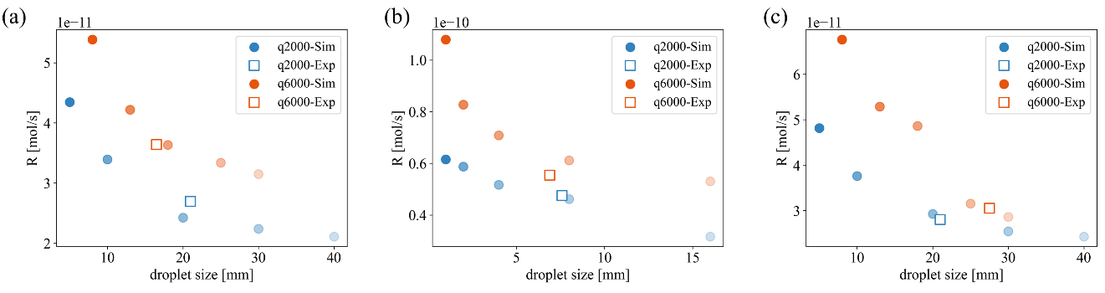
Figure S5. Bulk reaction rate from the SW two-phase flow simulations with different liquid slug lengths in comparison with experimental observations of channel 1-3 (a-c) at the flow rate of 2000 and 6000 μL/min.
Text S6
Figure S6 illustrates the velocity profiles at different conditions. Comparing cases at the same velocity but with different slug size and channel length, it is clear that when the slug length is shorter, the portion that is affected by evident internal circulations is larger.
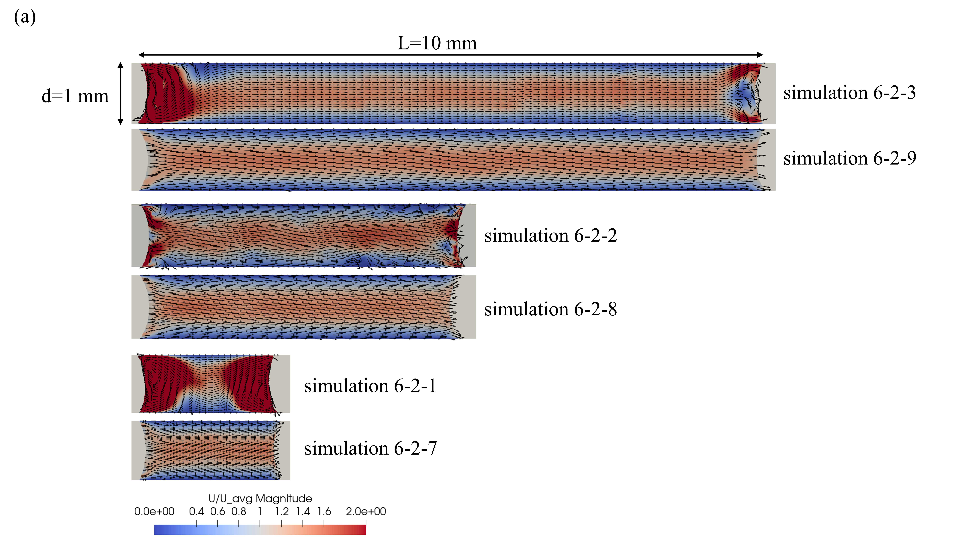
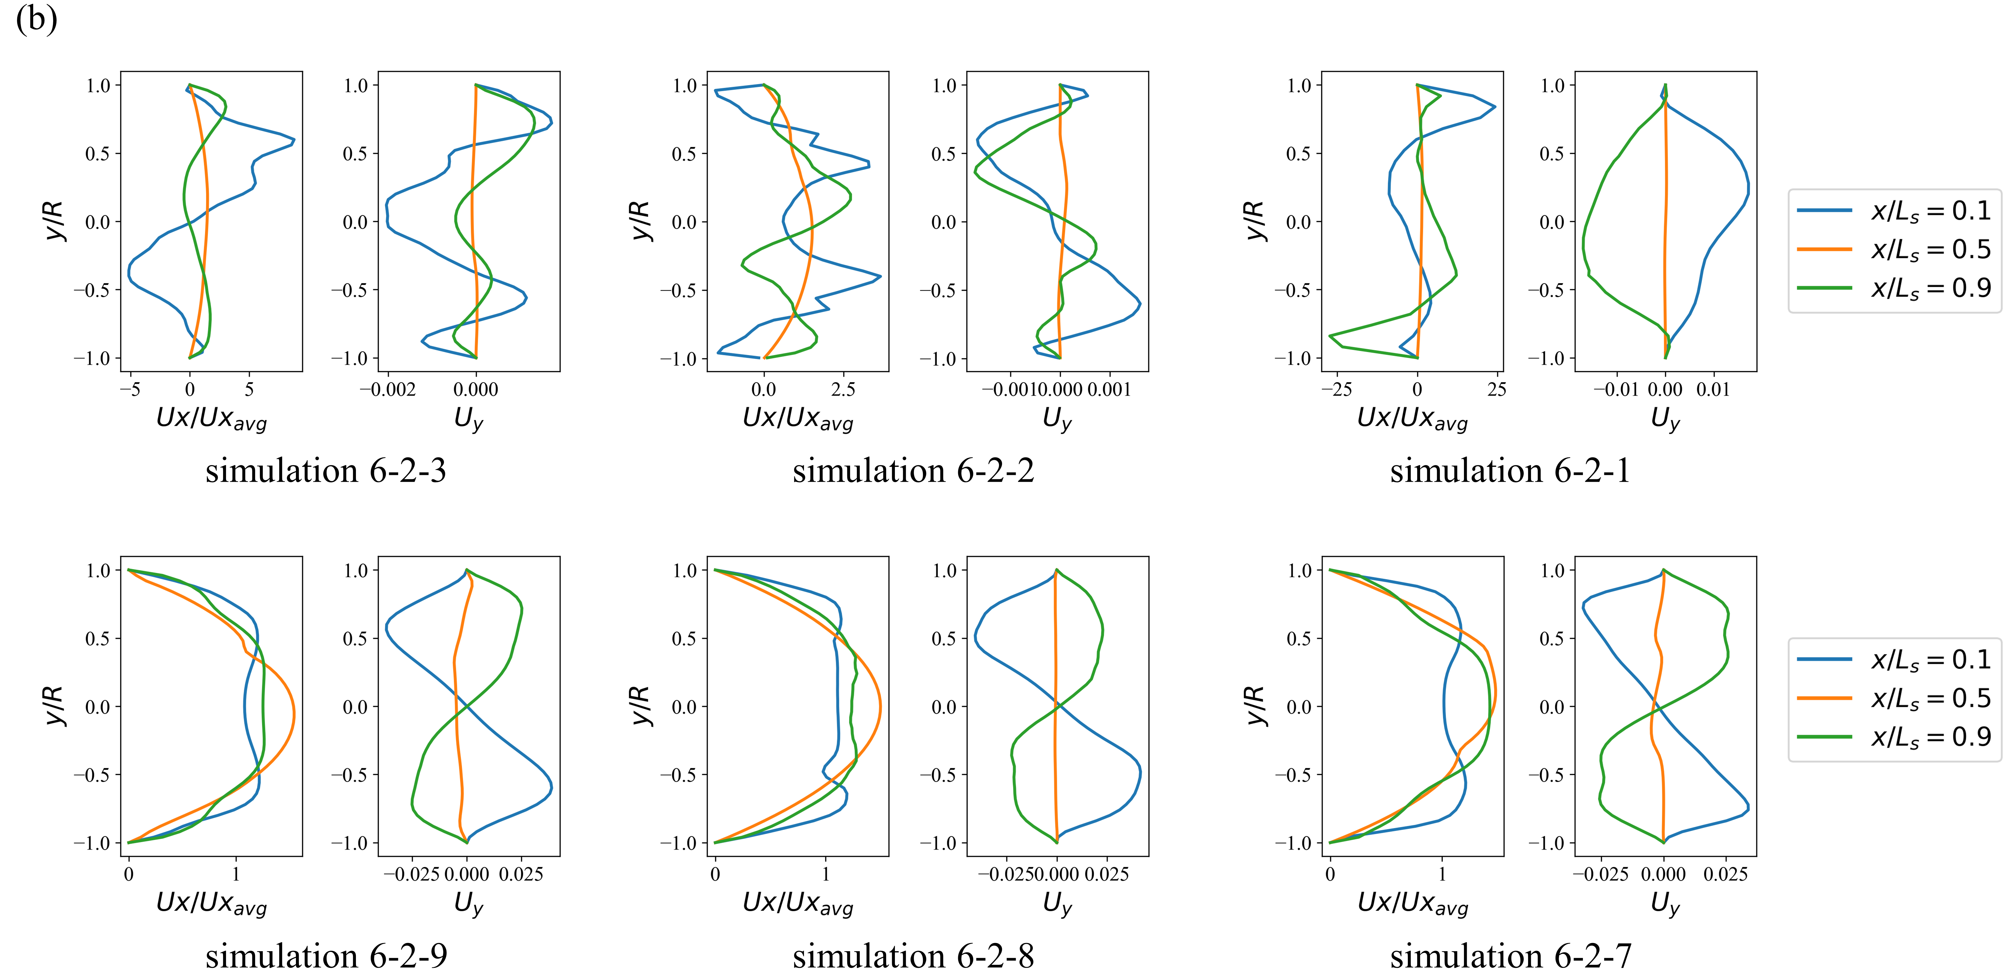
Figure S6. (a) Velocity fields and (b) selected vertical profiles for different slug lengths at different flow rates. The positions of the velocity profile correspond to locations within the droplet at x/Ls = 0.1, 0.5, and 0.9.The three sets of simulations correspond to channels with L=10 mm and d=1 mm and slug lengths of 10, 5, and 2mm. Within each set, the upper(lower) panel shows results from a flow velocity of 0.001 m/s (0.1 m/s). The simulation number labeled corresponds to conditions summarized in Table S2.

Text S7
Figure S7 illustrates that the for single-phase flow, the mass transfer coefficients and surface area averaged reaction rate calculated from the simulation results follow positive linear relationships with respect to theoretically calculated mass transfer coefficients in the log-log space. In particular, the regression relationship between the longitudinal mass transfer coefficient and the theoretical mass transfer coefficient is most statistically significant.
Figure S8 displays the correlation between mass transfer coefficients calculated from the simulation and the theoretically calculated mass transfer coefficients for two-phase flow conditions. In contrast to single-phase flow conditions, the transverse mass coefficients from the two-phase simulations follow a better regression relationships with respect to the theoretical calculations in general. However, evident data scattering is observed, and the regression results are poor.

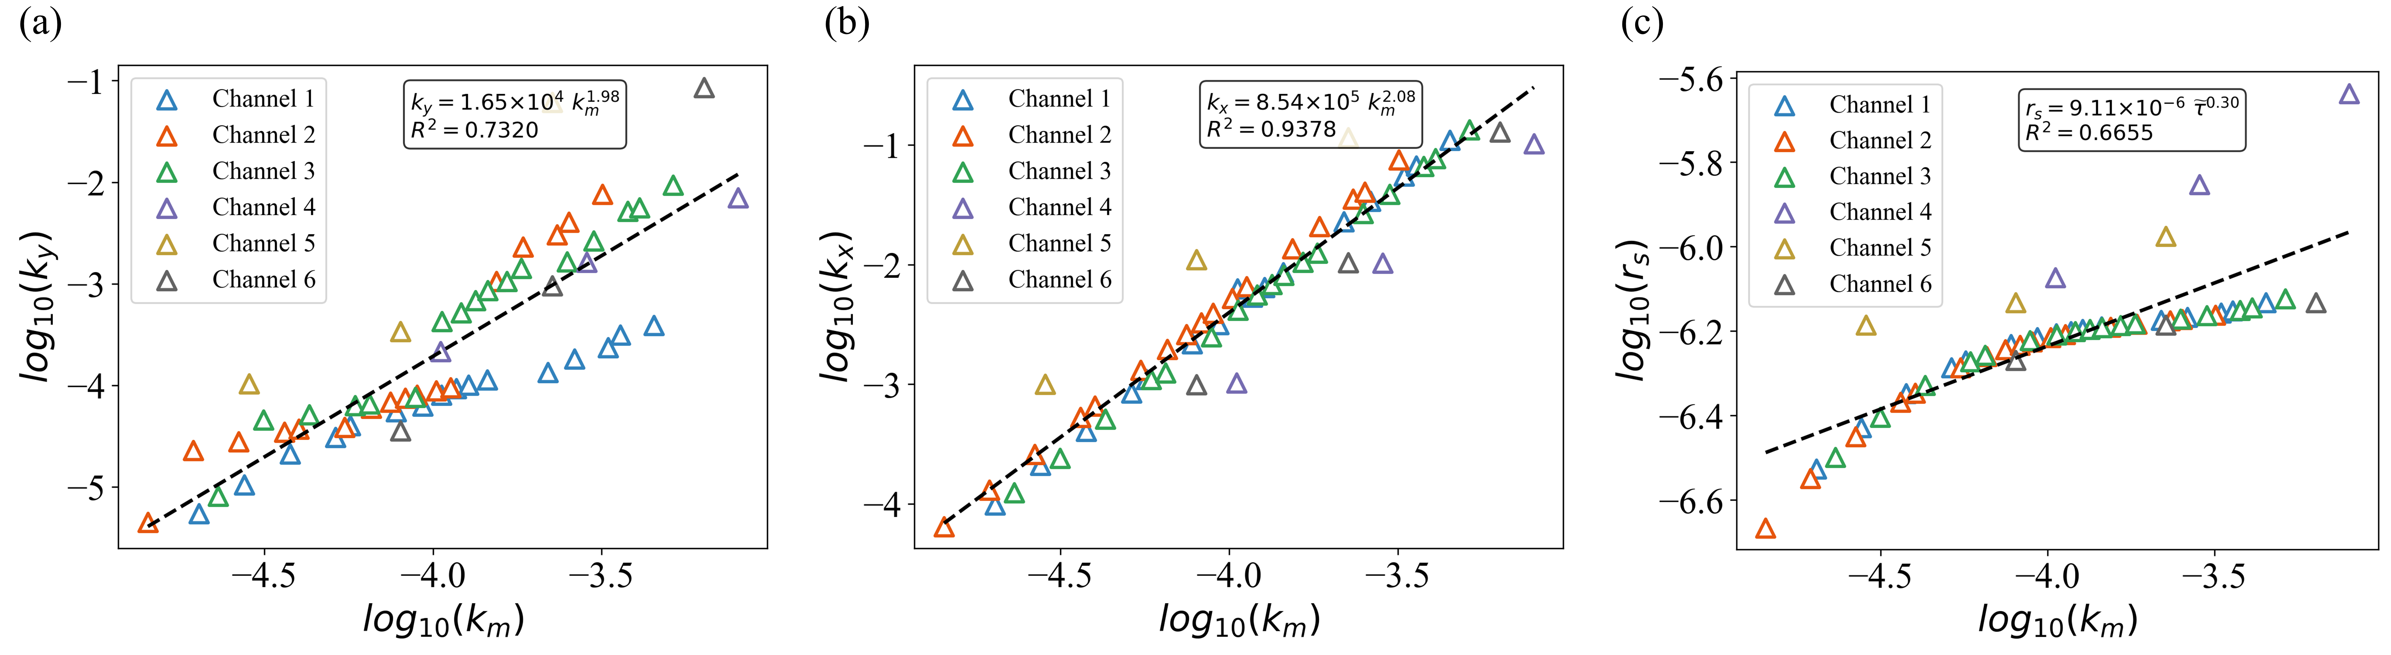
Figure S7. (a) transverse mass transfer coefficient (k_{y}), (b) longitudinal mass transfer coefficient (k_{x}), and (c) surface area averaged reaction rate (r_{s}) calculated from the simulations in relation to k_{m} in single-phase flow.
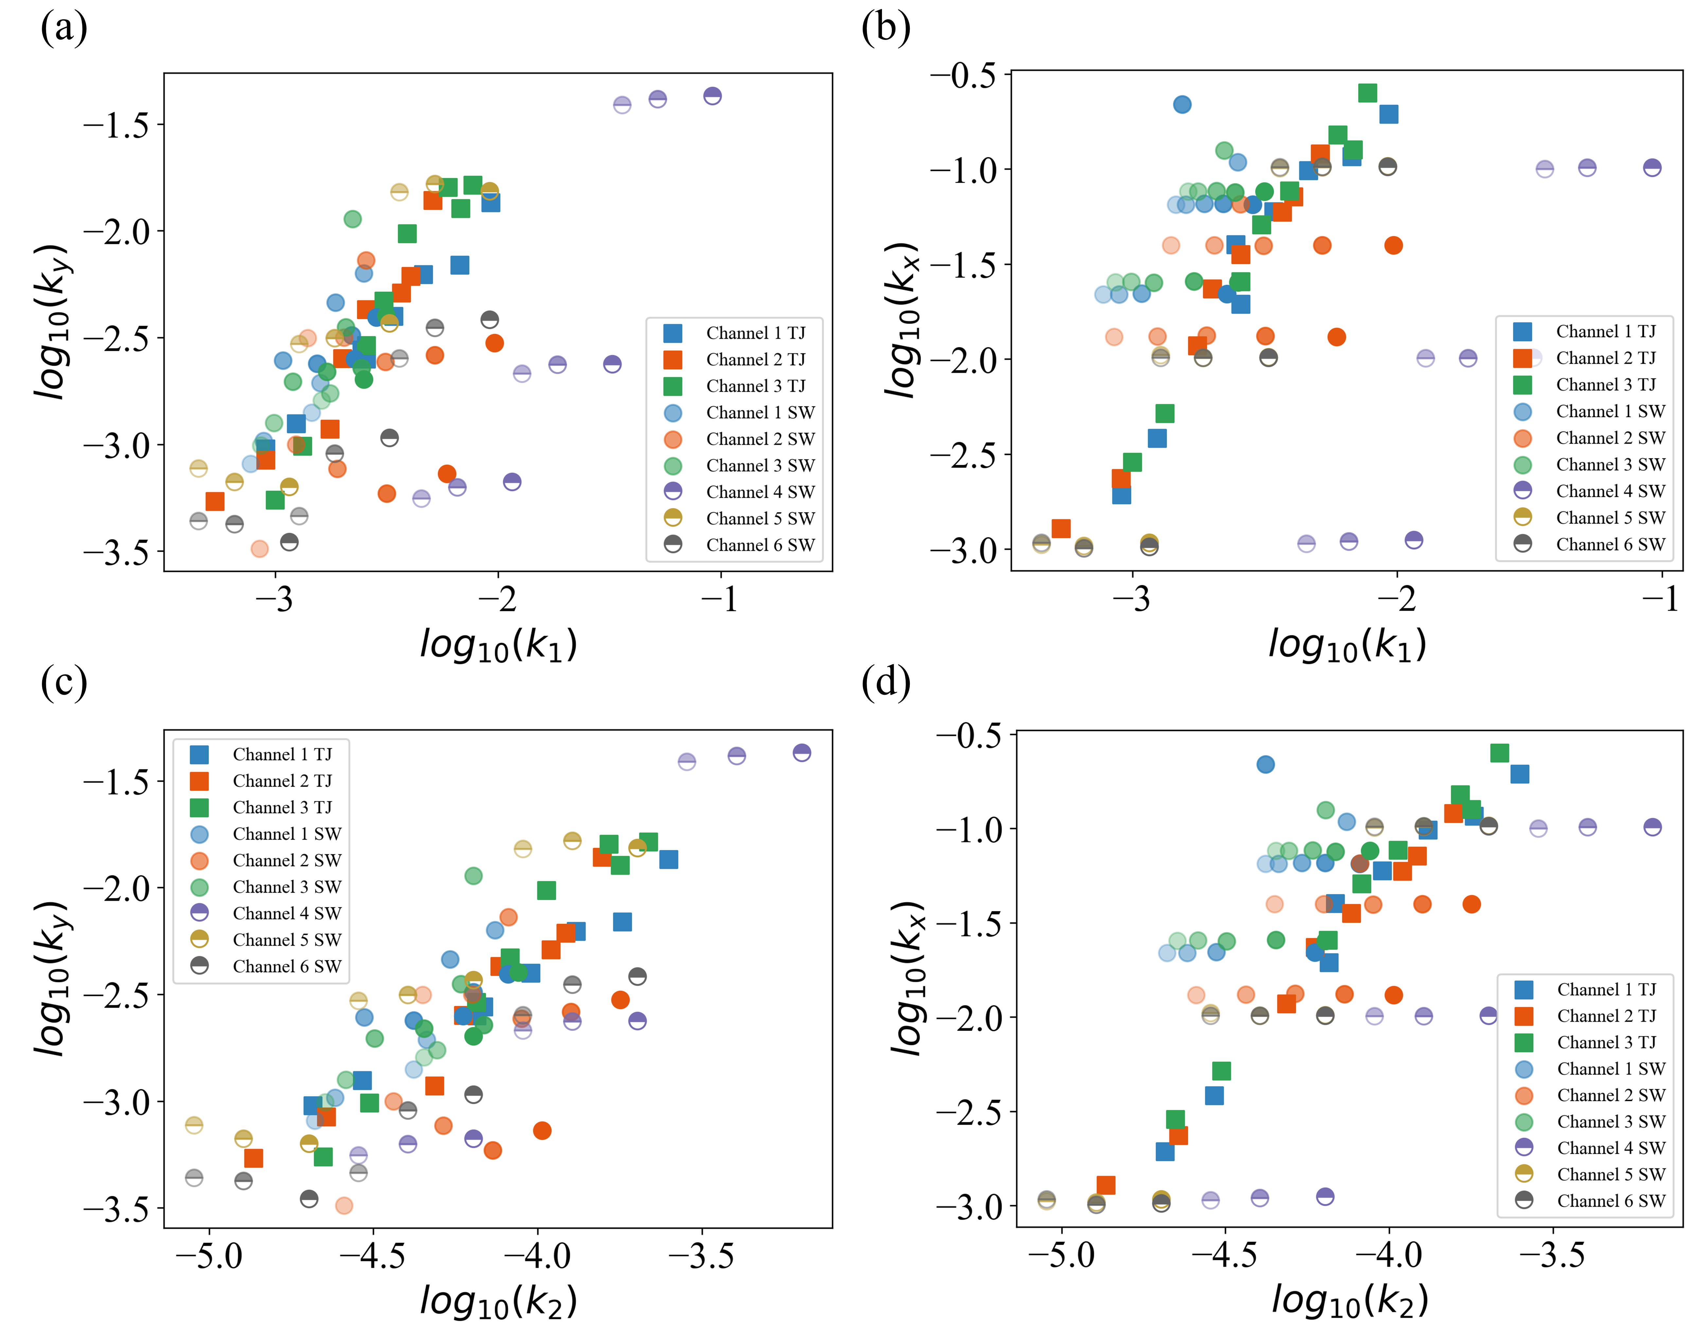
Figure S8. (a,c) transverse mass transfer coefficient (k_{y}) and (b,d) longitudinal mass transfer coefficient (k_{x}) calculated from the simulations in relation to k₁(a,b) and k₂(c,d) in two-phase flow. Lower color saturation corresponds to smaller slug length as detailed in Table S2.

